Experiment 6

Determination of Sound Wavelength anD velocity

using Standing Wave Phenomenon
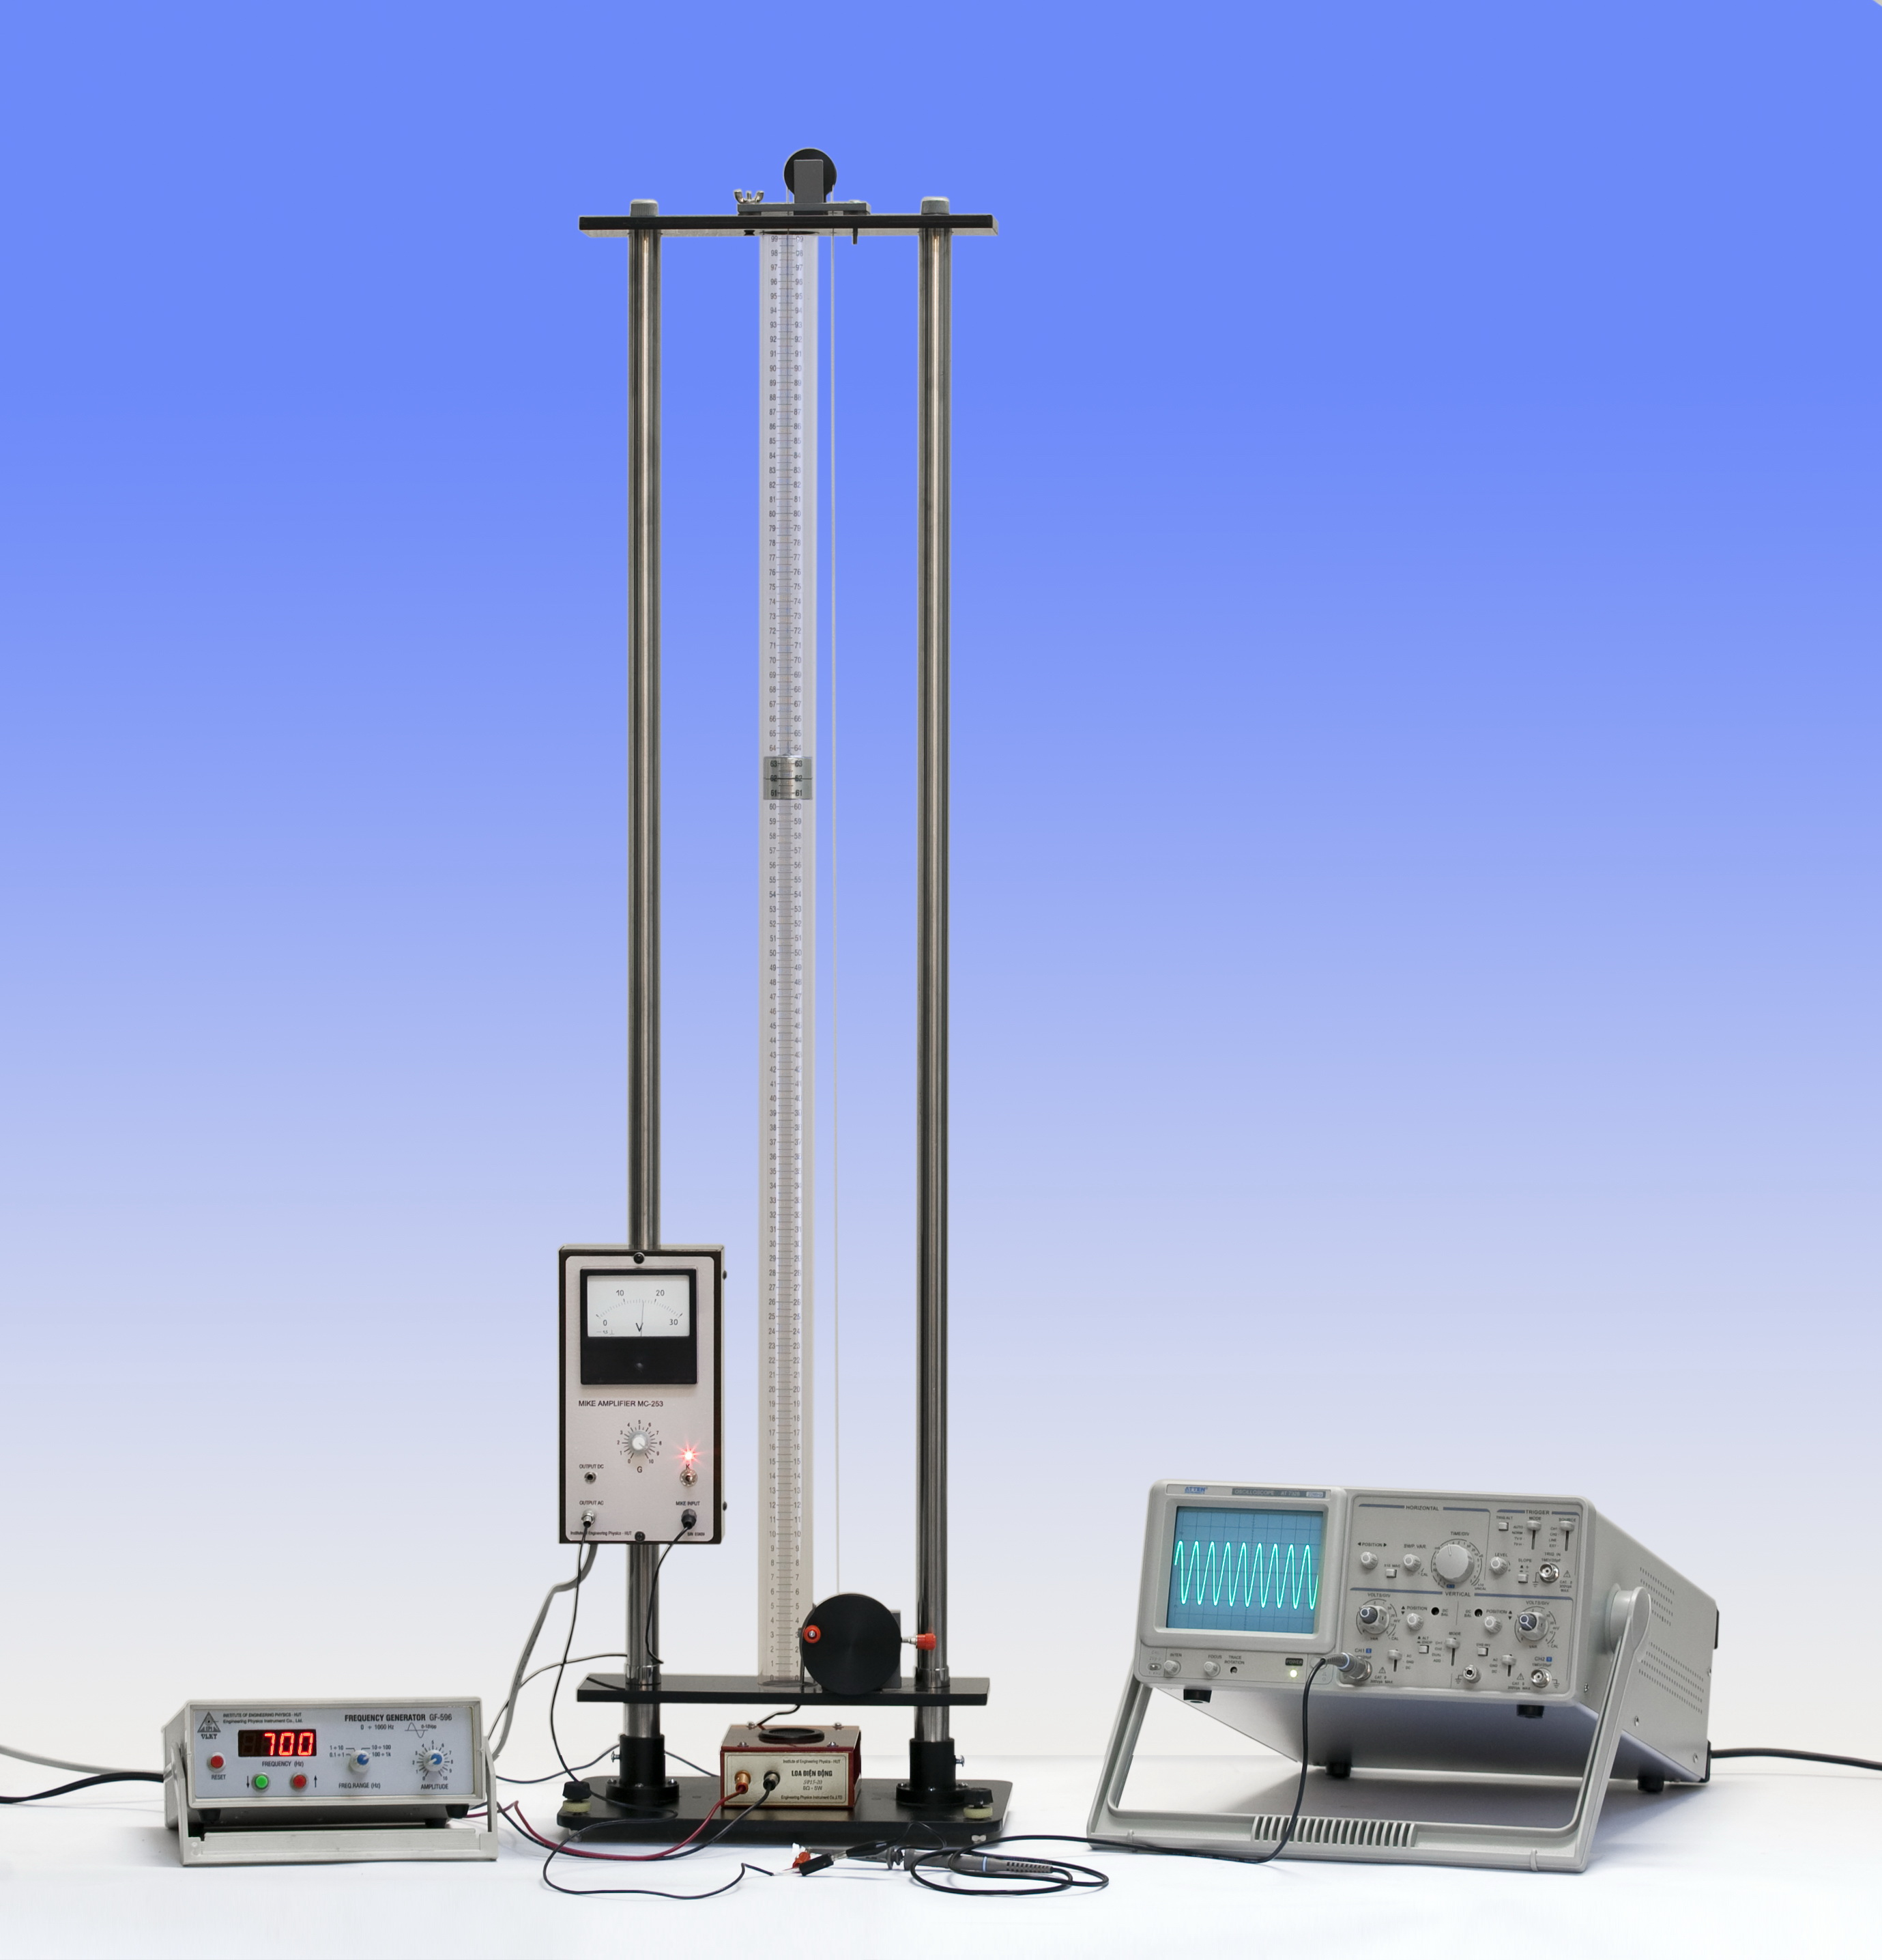
Figure 1. Equipment for measuring standing wave

Equipment

1. Glass tube for creating sound resonance;
2. Piston;
3. Electromotive speaker for transmitting the sound wave and microphone for detecting the resonant signal.
4. Function generator
5. Metal support and base-box;
6. The current amplifier with ampere-meter, MIKE
Purpose
To understand the physical phenomenon of standing wave and to determine the sound wavelength and propagation velocity.
I. background
A standing wave, also known as a stationary wave, is a wave that remains in a constant position. This phenomenon can arise in a stationary medium as a result of interference between two waves traveling in opposite directions. The effect is a series of nodes (zero displacement) and anti-nodes (maximum displacement) at fixed points along the transmission line as shown in figure 2. Such a standing wave may be formed when a wave is transmitted into one end of a transmission line and is reflected from the other end.
In this experiment, the standing wave will be investigated by equipment shown in figure 1. Here, the sound wave is generated by the frequency generator using an electromotive speaker. It travels along a glass tube and is reflected at the surface of a piston which can move inside the tube. These two waves with the same frequency, wavelength and amplitude traveling in opposite directions will interfere and produce standing wave or stationary wave.
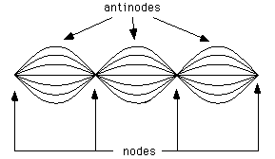

Figure 2. Illustration of standing wave

Considering a suitable initial moment t so that the incoming wave with frequency f making an oscillation at point N in form:
x_{1N} = a₀. sin2πft (1)
where a₀ is the amplitude of the wave,
Because of N doesn’t move (x_{N} = 0), then the reflective wave also creates an oscillation of which phase is opposite at N:
x_{2N} = -a₀. sin2πft (2)
It means that the algebraic sum of two oscillations is equal to 0 at N:
x_{N} = x_{1N} + x_{2N} = 0 (3)
On the other hand, considering a point M which is separated from N with a distance of:
y = MN
Let the velocity of the sound wave traveling in the air is v, then the phase of incoming wave at M will be earlier than that at N. In this case, the phase difference is denoted as:
Δt = y/v
The oscillation made by the incoming wave at M at moment t is the same as at N at moment t + y/v.
Then, we have: x_{1M} = a₀. sin2πf(t - y/v) (4)
In opposite, the oscillation made by the reflected wave at M will be later than that at N with an amount of y/v:
X_{2M} = -a₀. sin2πf(t + y/v) (5)
Using a trigonometric identity to simplify, the resultant wave equation will be:
x_{M} = x_{1M} + x_{2M} = 2a₀sin2πf (y/v) . cos2πft (6)
The sound wavelength λ (in meters) is related with the frequency f as the follows:
λ = v/f (7)
The amplitude of the resultant wave at M is
a = ⏐2a₀sin 2π(y/λ)⏐ (8)
Hence:
- The positions of nodes where the amplitude equals to zero are corresponding to
2π(y/λ) = kπ or y = k.(λ/2) (9)
where k = 0,1,2,3,…
- The positions of antinodes where the amplitude is maximum are corresponding to
2π(y/λ) = (2k+1).π/2 or y = (2k+1).(λ/4) (10)
where k = 0,1,2,3,…
It can be seen from eq. (9) and (10) that the distance between two conjugative nodes or antinodes is λ/2, that is:
d = y_{k+1} – y_{k} = λ/2 (11)
Therefore, if the water column in the glass tube is adjusted so that the distance L between its open-end and point N is determined as:
L = k . (λ/2) + (λ/4) where k = 0,1,2,3,… (12)
Then, there will be a nude at N and anti-nude at its open-end where the sound volume is greatest. Equation (12) is a condition to have a phenomenon of sound resonance or standing wave.
In this case, the sound resonance is detected by a microphone. The signal is shown by the ampere-meter of current amplifier. Then, the phenomenon can be recorded by observing the maximum deviation of ampere-meter’s hand corresponding to due to the position of piston. By measuring the distance between two conjugative nodes or antinodes the sound wavelength λ (in meters) and velocity of the sound wave can be determined using eqs. (11) and (7).

II. experimental procedure

- Step1: Switch the frequency knob on the surface of base-box to the position of 500 Hz
- Step 2: Turn slowly the crank to move up the piston and simultaneously observe the movement of ampere-meter’s hand until it gets the maximum deviation.
- Step 3: Record the position L₁ of the piston corresponding to the maximum deviation of ampere-meter’s hand in table 1 of the report sheet.
Note: The position L₁ is determined corresponding to the marked line on the piston.
- Step 4: Continue to move up the piston and observe the movement of microampere-meter’s hand until it gets the position of maximum deviation once again.
- Step 5: Again, record the second position of the piston L₂ (in millimeters) in table 1.
- Step 6: Repeat the experimental steps of 2 to 5 for more four times.
- Step 7: Perform again all the measurement procedures (from step 1 to step 6) corresponding to the frequencies of 600 Hz and 700 Hz. The measurement results are recorded in table 2 and 3, respectively.

Iii. Preparation

Learn the theoretical background to answer the following questions:
1. Definition of standing wave.
2. Description of the experiment equipment and the manner to create the sound standing wave in the experiment.
3. Wave traveling equation in elastic medium and its physical meaning.
4. Establish the expression to determine the standing wave amplitude and consequently the position of nudes and anti-nudes. Prove that the distance between two conjugative nodes or antinodes is a half of wavelength.

Experimental Report 6

Determination of Sound Wavelength

by using Standing Wave Phenomenon

Class:……………………………………..  Group:…………………………………….  Name:…………………………………….. | Verification of the instructors

I. Experiment Motivation
………………………………………………………………………………………………………………………………………………………………………………………………………………………………………………………………………………………………………………………………………………………………………………………………………………………………………………………………………………………………

II. Experimental Results

1. Measurement Results

Table 1

Frequency: f₁ = 500 1 Hz

Trial | 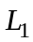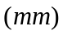 | 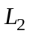 | 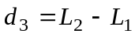 | 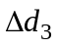
1
2
3
4
5
Average value |  |  | 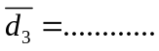  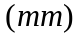 | 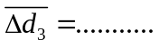

Table 2

Frequency: f₂ = 600 1 Hz

Trial
1
2
3
4
5
Average value

Table 3

Frequency: f₃ = 700 1 Hz

Trial
1
2
3
4
5
Average value

Apparatus accuracy:

2. Calculation of Average Value and Absolute Error of Wavelength

a. f = 500 Hz:

Hence:

b. f = 600 Hz:

Hence:

c. f = 700 Hz:

Hence:

2. Calculation of Average Value and Absolute Error of Sound Velocity

a. f = 500 Hz

Hence:

b. f = 600 Hz

Hence:

c. f = 700 Hz

Hence:

4. Theoretical velocity of sound wave and experimental values

Theoretically, the velocity of sound wave at a temperature T can be calculated as follows:
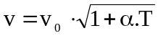
where v₀ = 332 m/s is the velocity of sound wave at temperature of 0 ⁰C, and α = 1/ 273 degree⁻¹
Calculate this value (take the value of room temperature depending on the measurement time) then compare it with the experimental results.

